Glow Zone

IMPRESSIVE GLOWING PERFORMERS WILL DAZZLE YOUR GUESTS!

LED Orchestra
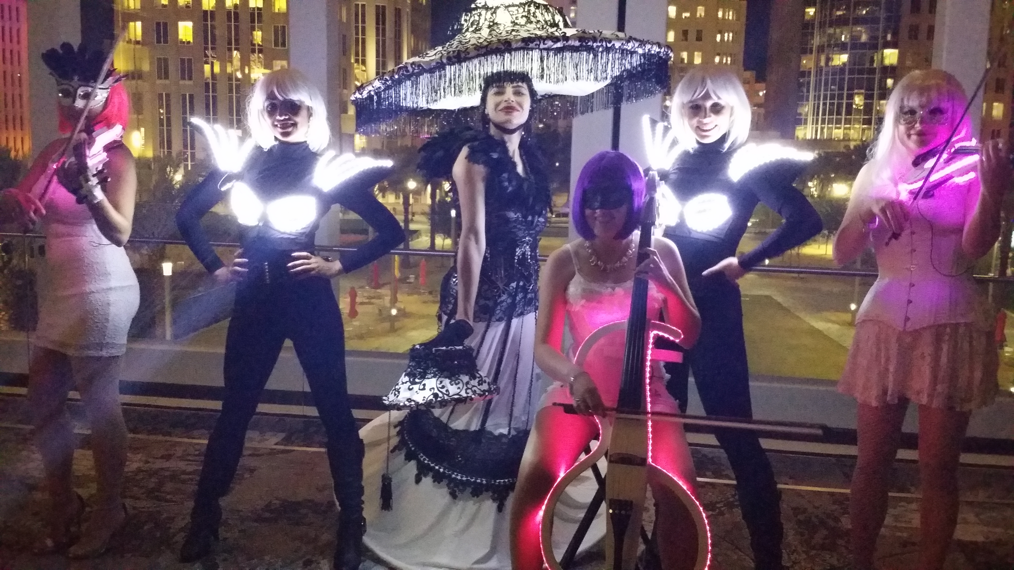
The night is young. Your guests will enjoy the sights and sounds of the LED Orchestra, complete with symphony musicians playing innovative instruments that light up and choreographed to music. As the DJ drops a beat, the musicians play along, giving the sound a sophisticated, classical feel to modern day hits. With the ability to roam throughout the room, your guests can network or dance the night away with the cast! Add our Electric Dancers or Living Lamp for more excitement and interaction!

Book the LED Orchestra as a SOLO (Violin), DUO (Violin, Viola), or TRIO (Violin, Viola, and String Bass), along with our DJ!

L.E.D. GODDESS
Watch her glow!

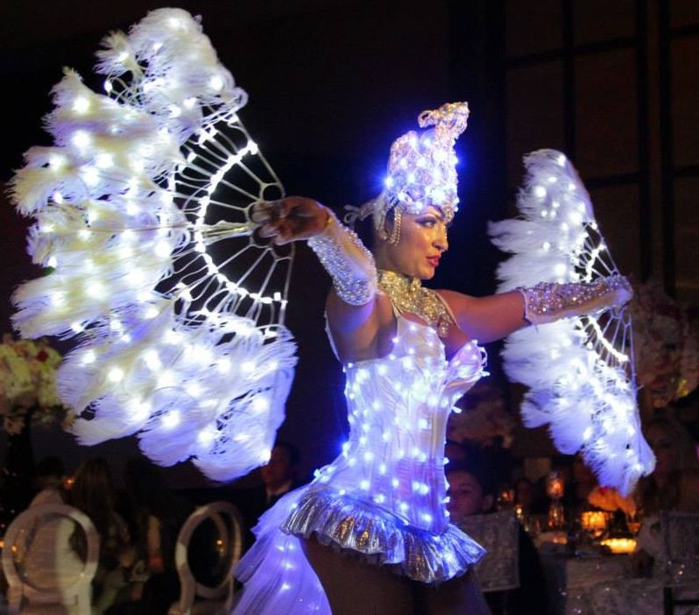
Our L.E.D. Goddess will invade your stage and perform a high-energy performance using ultra-bright props and lights. The planet is dark, and tonight she will light your party up. Much like a fire spinning act, this performance is full of acrobatic maneuvers and flashing lights creating a galaxy of pure excitement!
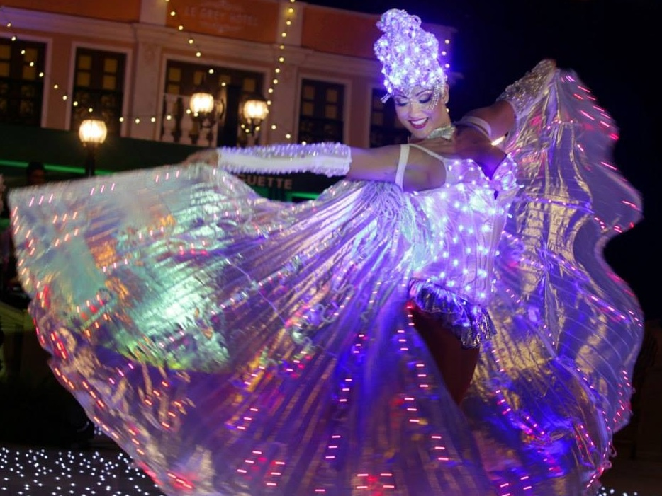

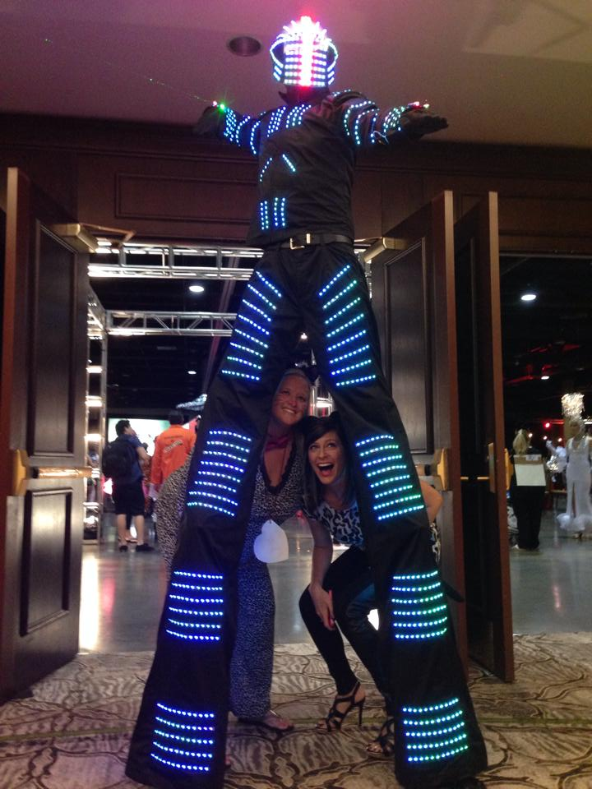

LED Stilts!

Technology and personality combine as our interactive LED Stilt lights up the night! Dance with him, take pictures, or rock to the beat of the music as this atmosphere performer becomes the main attraction.

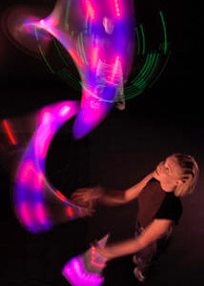

Electric Jugglers

The Electric Jugglers are an inventive team of juggling performers that incorporate world-class technique and intricate choreography. Set to a dramatic soundtrack, complex juggling patterns are performed in partial black light with lighted props to produce a breathtaking visual experience. A microprocessor at the heart of every club controls internal light emitting rays allowing the clubs to change color, strobe and synchronize with the music

Electric Dancers

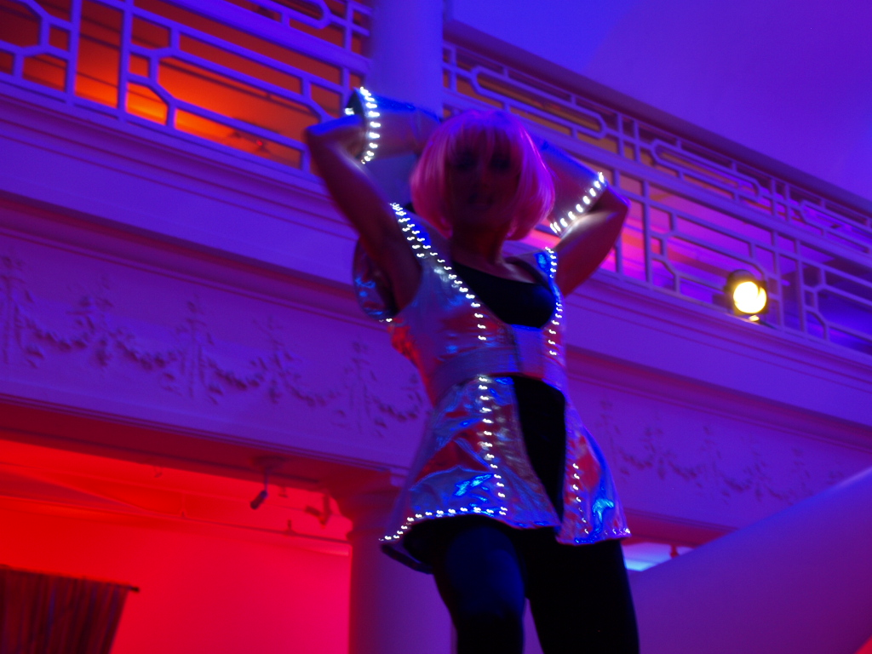
Electrifying, magnificent costuming and exquisite physical beauty, our Electric ensemble is a feast for the eyes. Our cast of female interactive electric dancers will provide non-stop activities to involve guests in the fun as well as offer an opportunity for the guests to take home some memorable photos. Two styles of costumes to choose from!

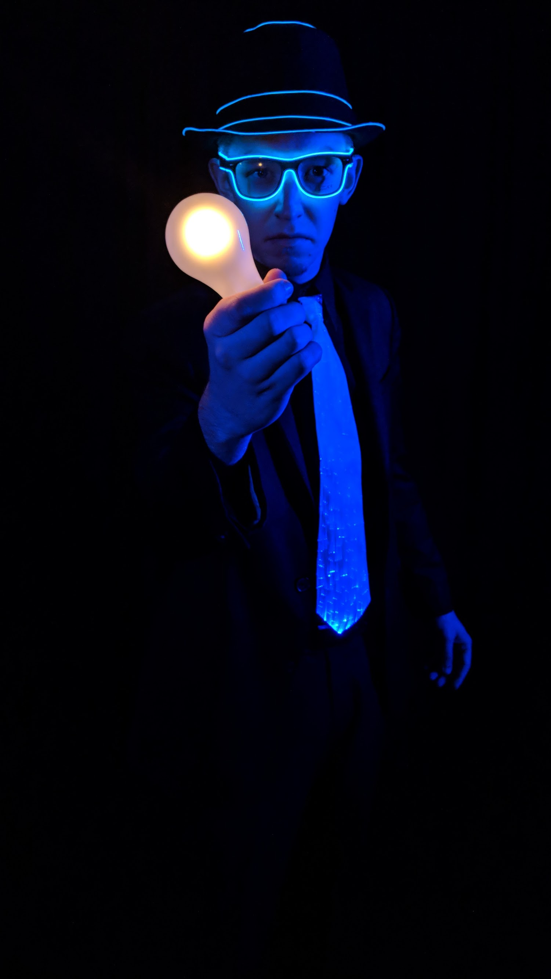

GLOW MAGICIAN

This act really POPS! The Glow Magician will be decked out in LED costuming and will perform street style magic with glowing props along with his standard bag of tricks.
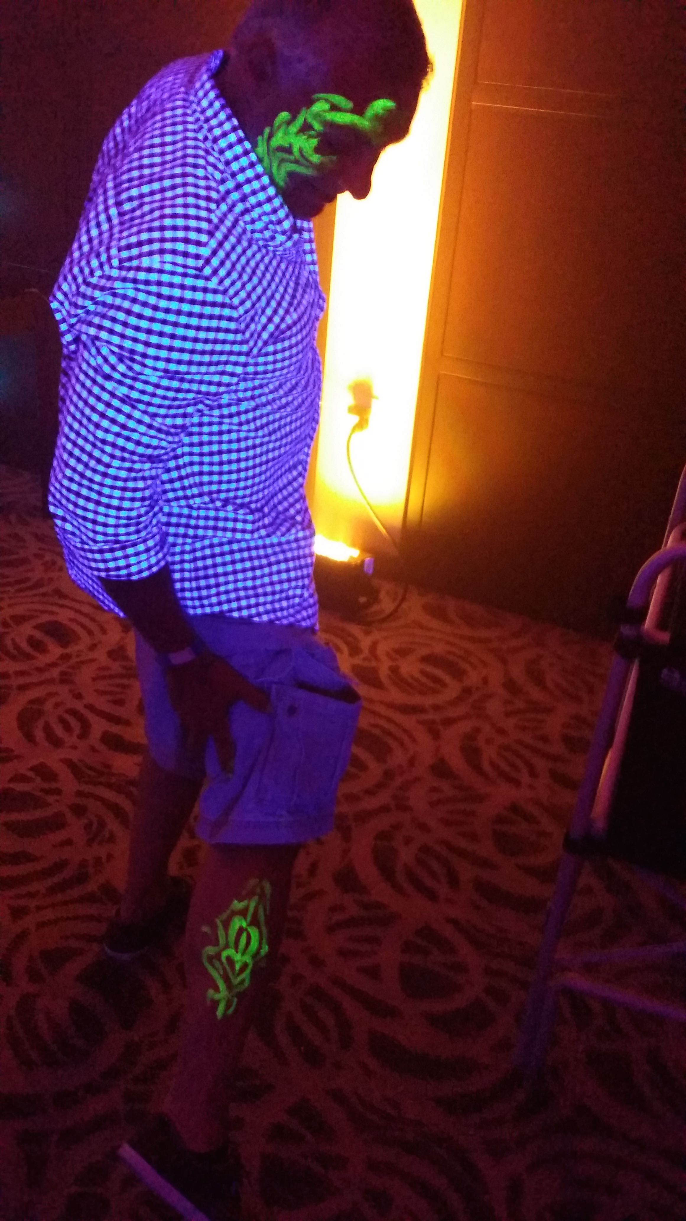
GLOW FACE PAINT!
Your guests will have a blast getting their face or boadies painting ith glow in the dark paint! Just tell them what you want including eye makeup, face, tattoos, etc. and they will create magnicficent artwork on your body that can easily be washed off later!

NOTE: You will need to illuminte the room with blacklight fixtures for paint to glow!

GLOW TATTOOS
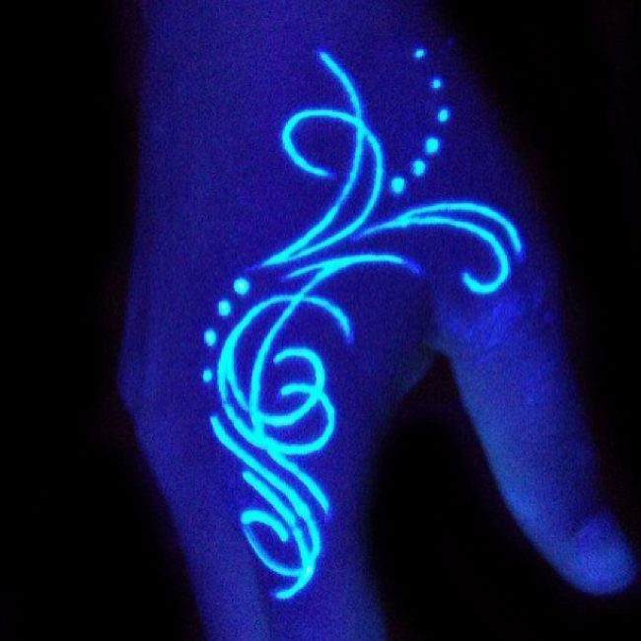
Express who you are…in tha DARK! In normal light you are your everday self, but when the lights go out your alter ego lights up! Our Glowing Tattoos will show your true colors!

GLOWING GRAFITTI WALL
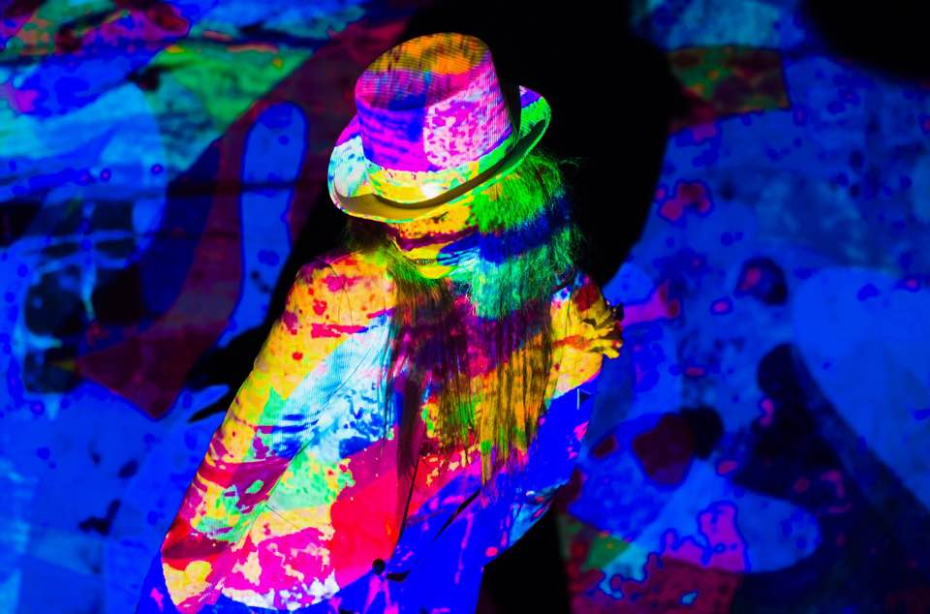
A blank canvass expodes into glowing colors as your guests work together with a professional artist to create a masterpiece! Using special paint and blacklight, your guests can create your company logo or anything you wish! You keep the painting, but remember, it will only show up if you have a black light fixture!

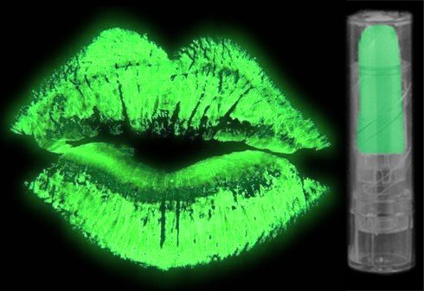
LIP STICK SCHTICK!

Our lip stick reader will tell your future using your lips! A lot can be told by following lines and creases in your lips! After your reading, re-apply your glowing lip stick and watch I glow!

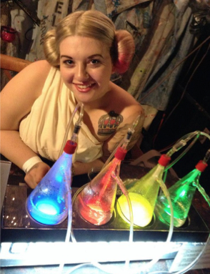
GLOW Oxygen Bar!

Your guests will enjoy a real BOOST to your energy level with an Oxygen Bar! This fun, interactive and healthy bar includes an attendant, unlimited nose hoses and 8 different aromas!

Oxygen is a great natural remedy for headaches and hangovers, mental alertness, strengthens the immune system and is a natural antibiotic! Just breathe baby, just breathe!

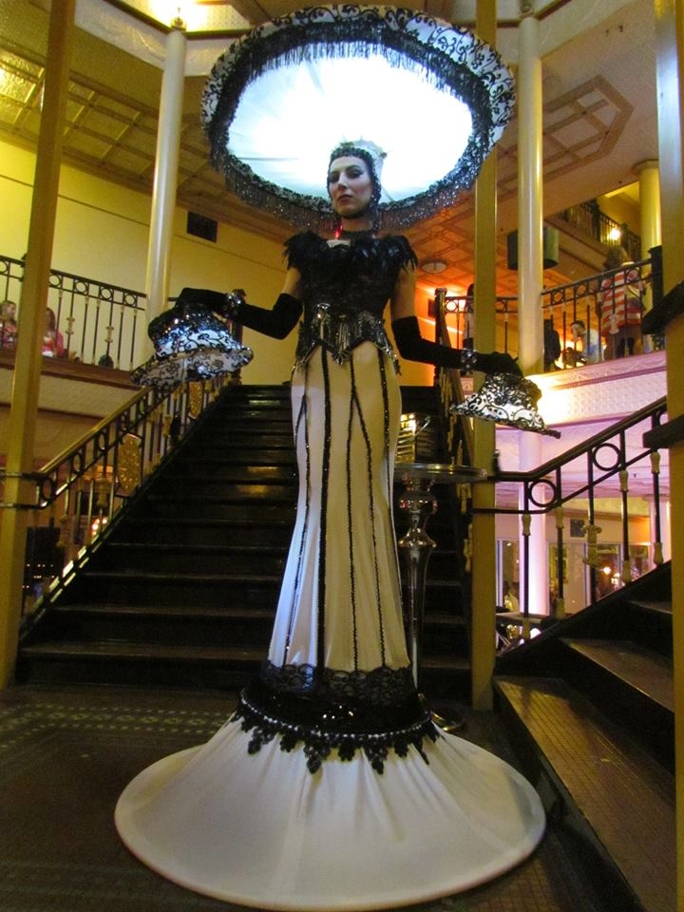
Living Lamps and Chandeliers
Not only are these unique art pieces, but they really light up! They will even strike up a conversation with you!

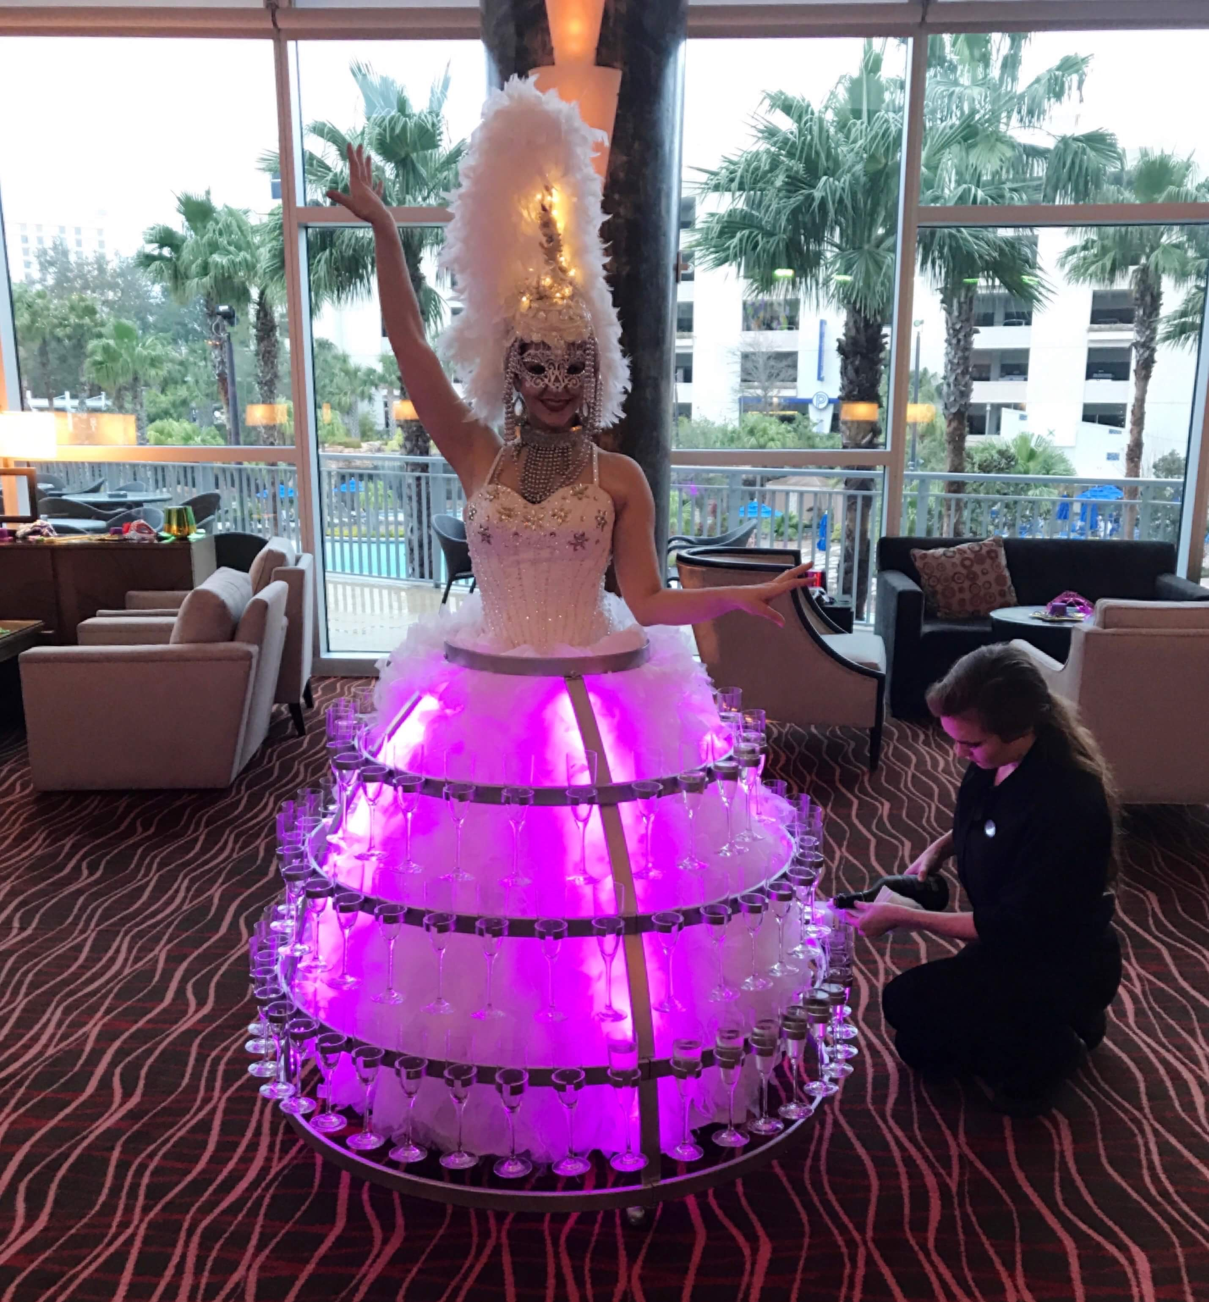
Glow Champagne Dress

Grab a glass of champagne from the beautiful Champagne Dress, decked out in colorful LED lights. They can change color to fit your décor!

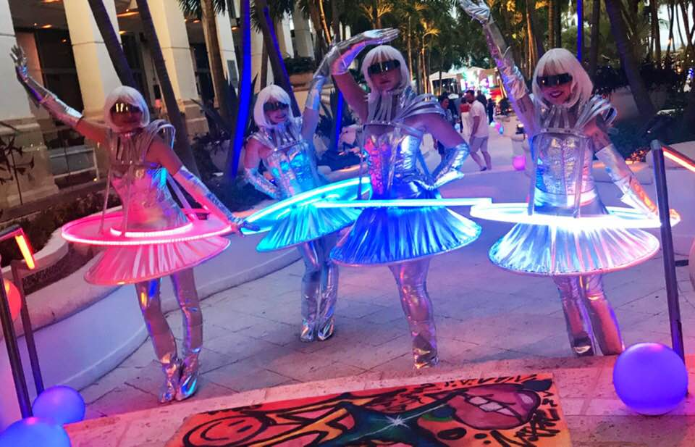

LED Tray Girls

Serve just about anything with the beatiful LED Trays! Easy to find in a crowded room!

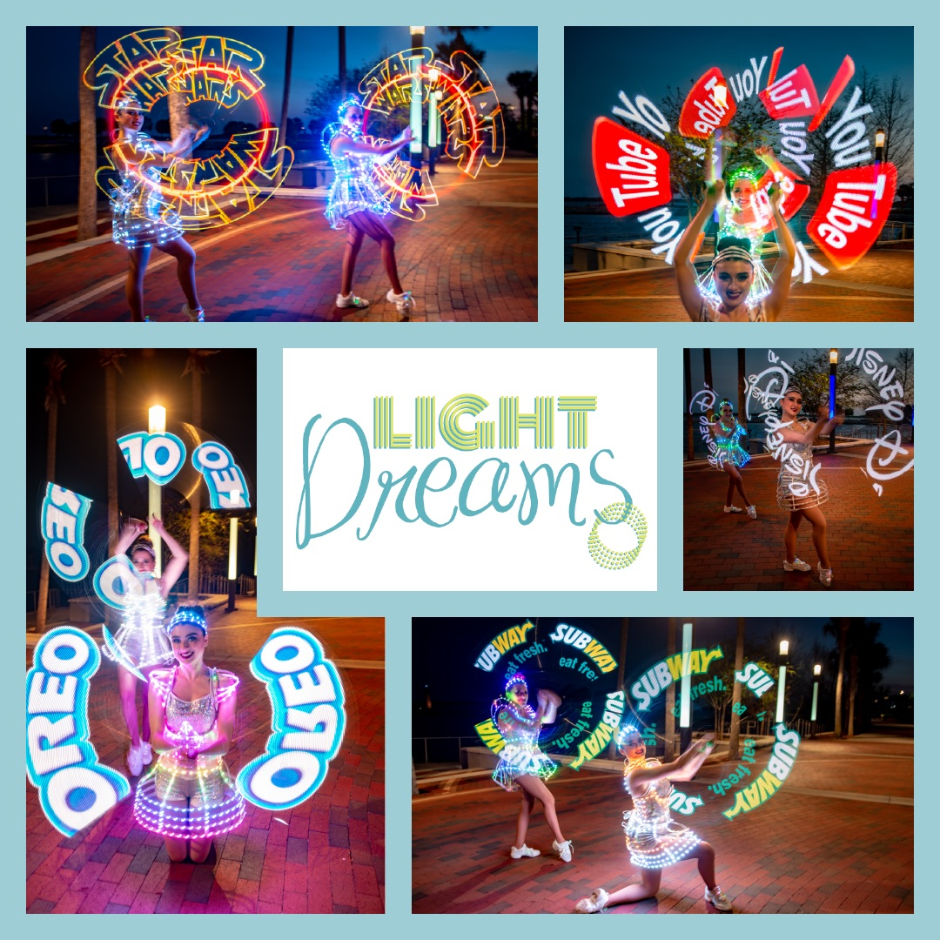
LED POI

Your company logo or messaging never looked better! Our amazing LED POI Spinner will create colorful light-up custom designs!

DJ FLASH!
DJ Flash is a multitalented Disc Jockey/Emcee, originally from New York City. Now based in Florida, DJ Flash has brought is big ciy mixes to the Sunshine State and will turn your party upside down! Flash also speaks fluent Spanish and can DJ Latin parties as well! He has performed with such artists as Kook & The Gang, Boys2Men, and more.

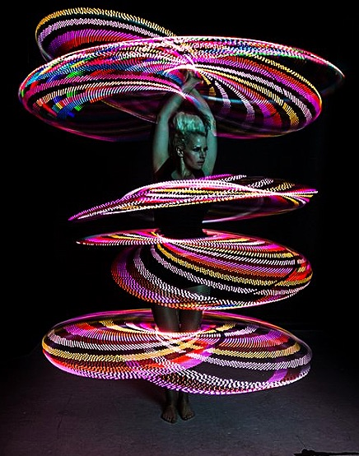

LED Hula Hoops!

This solo act is an energetic crowd-pleaser, using LED hoops, which are programmed to display spectacular colors & shapes throughout the act. The performer manipulates the hoops using all parts of her body, adding the hoops one-by-one until several hula hoops circle her body in unison. This unusual display of control will liven-up any party or event!

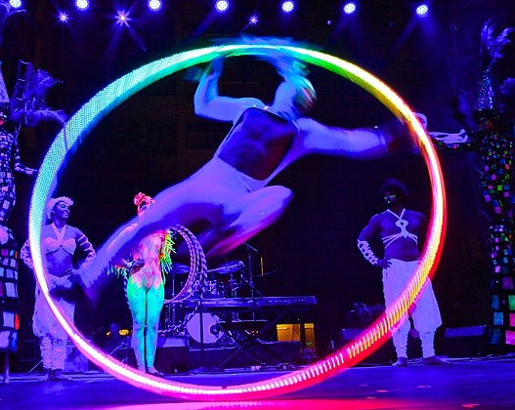
LED Cyr Wheel

This act is performed on a circular apparatuses, creating a kaleidoscope of patterns utilizing innovative programmed LED lights. The apparatus is manipulated by an acrobat with amazing control, balance & precision, articulating each movement in this fluid, yet energetic & daring act.

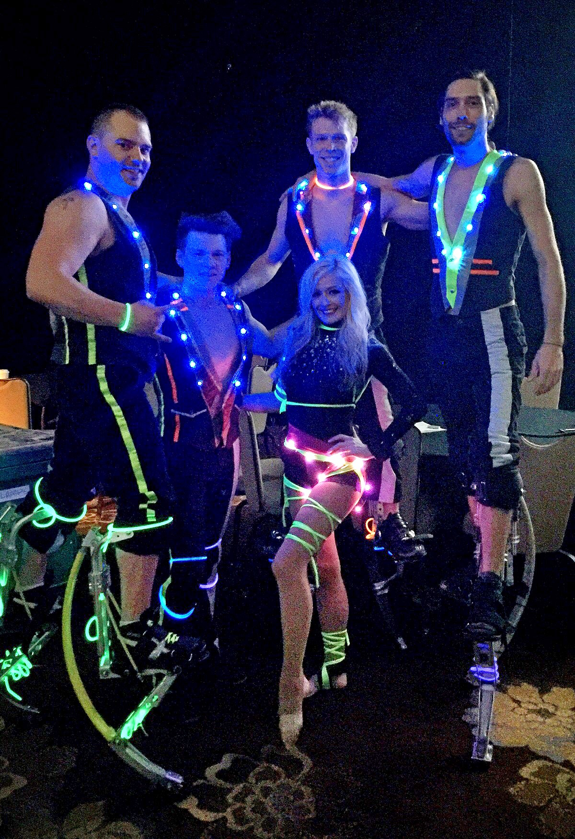
LED Power Skips

This explosive act features “jumping stilts,” an innovative fusion of extreme pogo stick and stilts, allowing performers to propel themselves 15 feet in midair as they jump and flip. Power Skips can be performed either as a 5-7 minute act demonstrating acrobatic choreography set to high-energy music, or can be used for ‘ambiance-style entertainment,’ in which the performers jump, stroll & interact with crowds for a set time period, creating an energetic atmosphere for any event. The boots are extremely agile, allowing performers to run through a crowd, jump off a stage and tumble on pavement.

Shadow Dancers

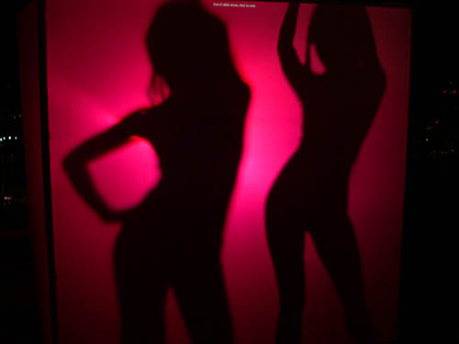
Our beautifully shaped Shadow Dancers will perform sultry moves behind a scrim. Your guests may be curious as to what they really look like!

Trampoline Wall
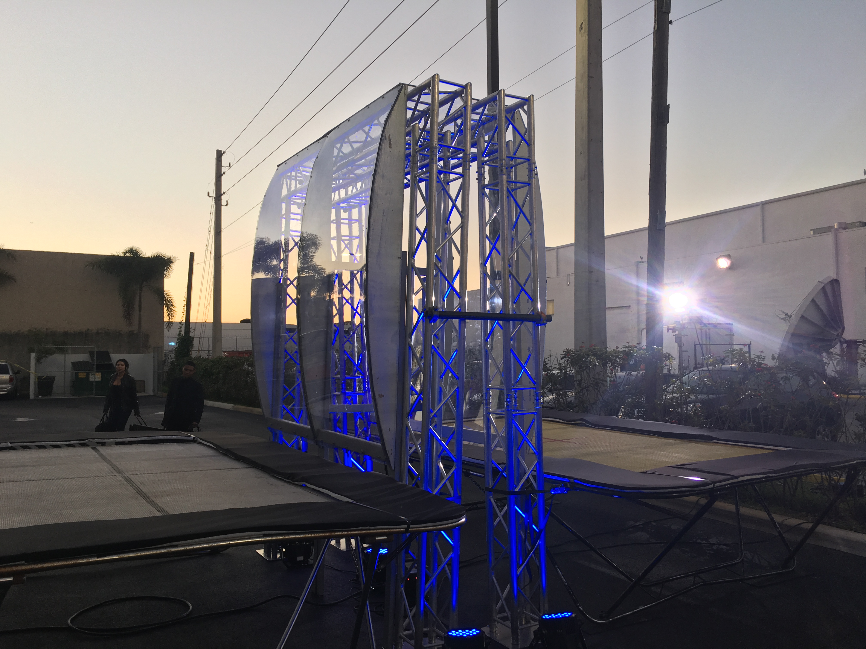
This athletic, crowd-pleasing act features two enormous Olympic-style trampolines positioned on each side of a 12 foot wall, in which AntiGravity acrobats leap, fall, and flip from with incredible height and accuracy. Our highly-skilled gymnasts dramatically jump off of the wall onto the trampoline structures and walk vertically up the wall back to the top, using either side to perform difficult acro combinations resembling ‘extreme parkour.’ The act builds in intensity as the acrobats fly through the air, performing daring tumbling tricks, partnering combinations, and explosive group choreography. This custom-made structure and exciting choreography with impress all audiences!
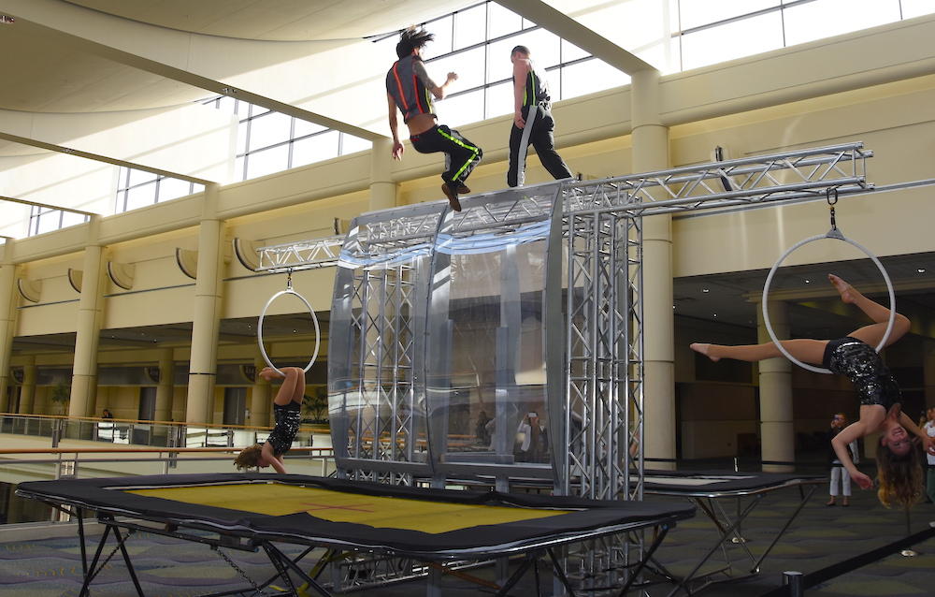

GLOW MEN!
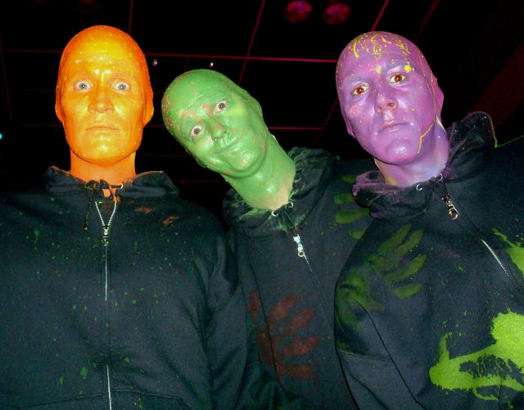
Our wildly interactive and quirky style of Blue Man Group style actors will keep your guests laughing throughout the night. Dance with them, laugh with them, take pictures with them, or just plain party with them! These guys are the life of the party!

CONGA GLOW!
Interactive Glow Conga Drums with DJ!
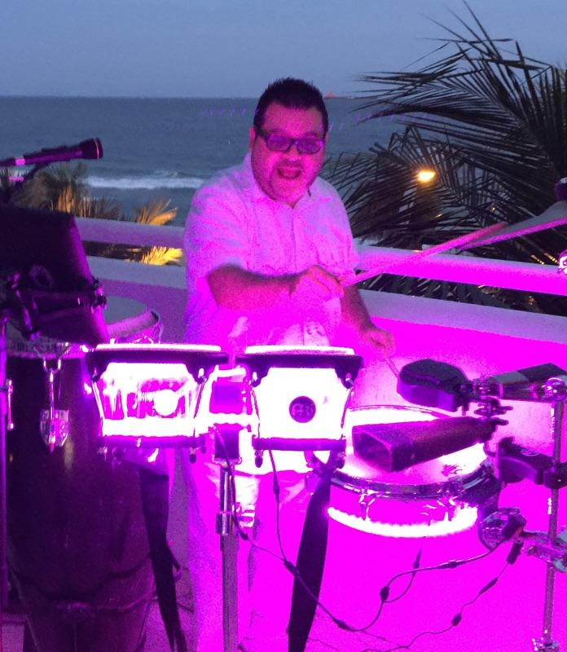

Add some festive Miami flavor with a high energy DJ and Glowing Conga Drums! Your guests can bang along to the beat of the drum as our Conga Drummer jumps into the crowd and invites your guests beat on his glowing drums. The DJ will continue to spin the hits and take requests!
